| FULL LEGAL NAME | **LOCATION (COUNTRY)** | **EMAIL ADDRESS** | **MARK X FOR ANY NON-CONTRIBUTING MEMBER** |
| --- | --- | --- | --- |
| Mphikeleli Mbongiseni Mathonsi | South Africa | mphikelelimm@gmail.com |  |
|  |  |  |  |
|  |  |  |  |

| **Statement of integrity:** By typing the names of all group members in the text boxes below, you confirm that the assignment submitted is original work produced by the group (excluding any non-contributing members identified with an “X” above). | |
| --- | --- |
| **Team member 1** | Mphikeleli Mbongiseni Mathonsi |
| **Team member 2** |  |
| **Team member 3** |  |

| Use the box below to explain any attempts to reach out to a non-contributing member. Type (N/A) if all members contributed.  **Note:** You may be required to provide proof of your outreach to non-contributing members upon request. |
| --- |
|  |

**Step 2: Portfolio Selection Problem Description**

This should outline how a portfolio selection problem can be viewed as a multi-armed bandit problem in an insight from Huo et al. (2017). Also, state the pseudocode of Model 1 in the paper-based sequential decision-making algorithm for this problem.

**2(a) Portfolio Selection as Multi-Armed Bandit Problem**

Portfolio selection is a problem in financial mathematics concerned with the choice of a subset of the available financial assets with which to constitute the portfolio, such that return is maximized by keeping risk under control. Considering the problem as an MAB allows the literature to continuously learn and adapt over time:

* Arms: Each "arm" corresponds to an individual asset; for example, stocks, bonds, or commodities.
* Reward: This is given by the return coming from each asset during a certain period.
* Risk Management: The framework incorporates both the expected returns and associated risk (volatility) of each asset. This can also be called a risk-aware MAB problem.
* Objective: To optimize the cumulative portfolio returns over time by balancing exploration-exploitation trade-offs - exploring new assets to learn more about their returns and risks versus exploiting known profitable assets.

This ensures that the selection of the portfolio is adaptive, something particularly important in fluctuating market conditions. Given the dynamic selection of assets based on their performance, this model fits well with the needs of portfolio managers to maximize returns with controlled potential risks (Markowitz, 1952; Huo et al., 2017).

**2(b) Portfolio Selection Algorithm-Pseudocode Outline**

Following is the outline of the pseudocode for the implementation of sequential decision making using a risk-aware MAB framework:

1. Initiate:

* Sets the initial portfolio weights and observed returns for every asset. Defines the risk tolerance level and reward/risk balance parameter. Initializes the accumulated reward and risk metrics.

2. For every time period, t:

* Calculating the expected reward and risk of each asset given the past data in each time step.
* The risk-aware selection criterion selects those assets showing the best return-to-risk ratio.

3. Selection Phase:

* The goal here is to select an asset or a subset of assets to include in the portfolio. Selection is based on:

a) Exploration: The random selection of assets serves to collect more data about their performance.

b. Exploitation: Select the asset that has the maximum expected return-to-risk ratio.

4. Update Phase:

* Update the composition of the portfolio with selected assets.
* Re-evaluate Cumulative Return and Risk for the Updated Portfolio
* Store the observed return of the selected assets; update Expected Reward and Risk Metrics for.

5. Repeat steps for the next time period until at the end of the investment horizon.

**Explanation of the Pseudocode**

* Initialisation: This provides the initial settings for the portfolio, such as the weights of assets, risk factors, and base performance metrics.
* Selection Phase: It balances exploration and exploitation through selection of assets to enter the portfolio in terms of a risk-aware return-to-risk ratio.
* Update Phase: Updates performance metrics and the composition of portfolios using new data as input to continuously tune future decisions.

**Implications for Portfolio Management**

Risk-awareness in this model serves as the backbone of any kind of investment management in turbulent times in the market. The adaptive learning within the MAB framework will ensure better decision-making based on the trade-off between risk and return established by Markowitz's modern portfolio theory (Markowitz, 1952). This dynamic balancing of exploration and exploitation increases a portfolio manager's ability to handle market fluctuations while taking up high-reward opportunities with controlled risk associated with them (Huo et al., 2017; Sutton & Barto, 2018).

**Step 3: Data Collection - Member A**

**Objective**

Collect daily return data of chosen stocks in the S&P 500 Index during the volatile market - for instance, a subprime mortgage crisis from September to October 2008 - for further analysis and application of the multi-armed bandit model to determine the best portfolio.

**3(a) Stock Selection**

Data collection from the following will be required by Member A to capture a wide range of market behavior:

* 15 Financial institutions such as major banks, investments
* 15 Non-financial institutions such as Technology companies, Consumer goods, Industrials

These kinds of stock selections will render a diversified dataset which reflects the performance of the different sectors during the time of a financial crisis. In this way, it is possible to analyse various risk and return dynamics.

**3(b) Sources and Data Collection Methodology**

Data Source:

* **Yahoo Finance:** access to the web for obtaining historical financial data. It contains daily stock prices, which can be used as the base for the calculation of returns on a day-to-day basis.
* **Python Library:** Use the yfinance library to automatically extract the information from the web for the selected stocks.

The logic for Approach:

* **Fetch daily historical** adjusted closing prices for each of the selected stocks for the dates September 1, 2008, to October 31, 2008.
* **Calculate daily returns** using the formula:

**3.1.1**

Where ​ is the daily return, is the adjusted closing price on day , and is the adjusted closing price on the previous day.

**3(c) Difficulties and Contingencies**

* Gaps in Data: The data must be available for all tickers during the selected period. If for some days or some stocks, data is not available, either take other stocks or deal with such gaps with proper data cleaning techniques.
* Return accuracy: verify that returns are calculated using the adjusted closing prices for the dividend and split to make sure accurate returns are computed.
* Historical Context: The subprime mortgage crisis deeply affected the financial and non-financial sectors differently. This difference will serve useful in drawing conclusions from the results provided by the risk-aware multi-armed bandit model.

**Step 4: Correlation Matrix and Heatmap**

Objective.

The objective here is to calculate the correlation matrix for the daily return collected in Step 3 and prepare a heat map to visualize the result. It tries to establish the linkage between the chosen stocks and studies clustering of highly correlated stocks. It also talks about the different criteria used to sort the securities in order to make it better to visualize.

**4(a) Correlation Matrix Calculation**

1. **Definition**: The correlation matrix is a table that provides the values of the correlation coefficients for several sets of variables. Each cell in the table represents the correlation between any given two assets' returns, which gives insight into how closely they are moving with one another.
2. **Mathematical Expression**:

where is the covariance between the returns of assets and , and and are their respective standard deviations.

**4(b) Sorting and Visualizing Highly Correlated Stocks**

1. **Sorting Criteria:** We want the stocks sorted in such a manner that the highest correlated stocks are located close enough to each other, so we can generate good clarity on the heatmap.

* We do this by sorting the rows and columns by hierarchical clustering.
* Grouping of stocks into similar sectors; for example, financial institutions should be separated from non-financial.

1. **Explanation:** Highly correlated stocks often depend on similar market factors, such as sector-specific trends or macroeconomic variables. As an example, during the sub-prime mortgage crisis, financial stocks were likely to have been more correlated with each other than with non-financial stocks since they shared a similar vulnerability to mortgage-backed securities and credit risk.

**Results:**  
  
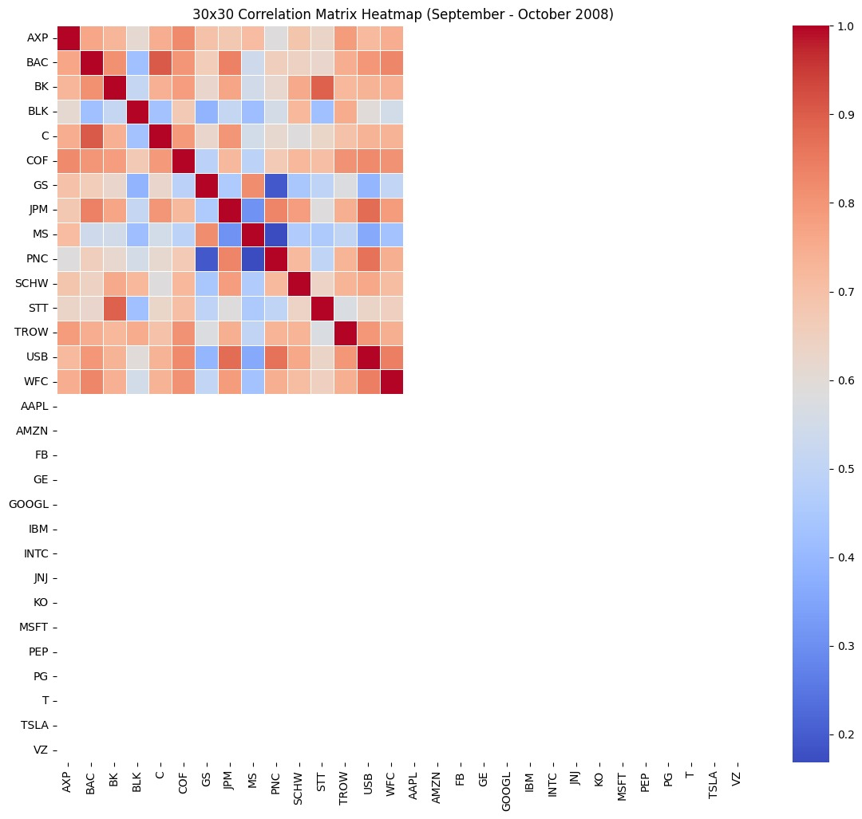

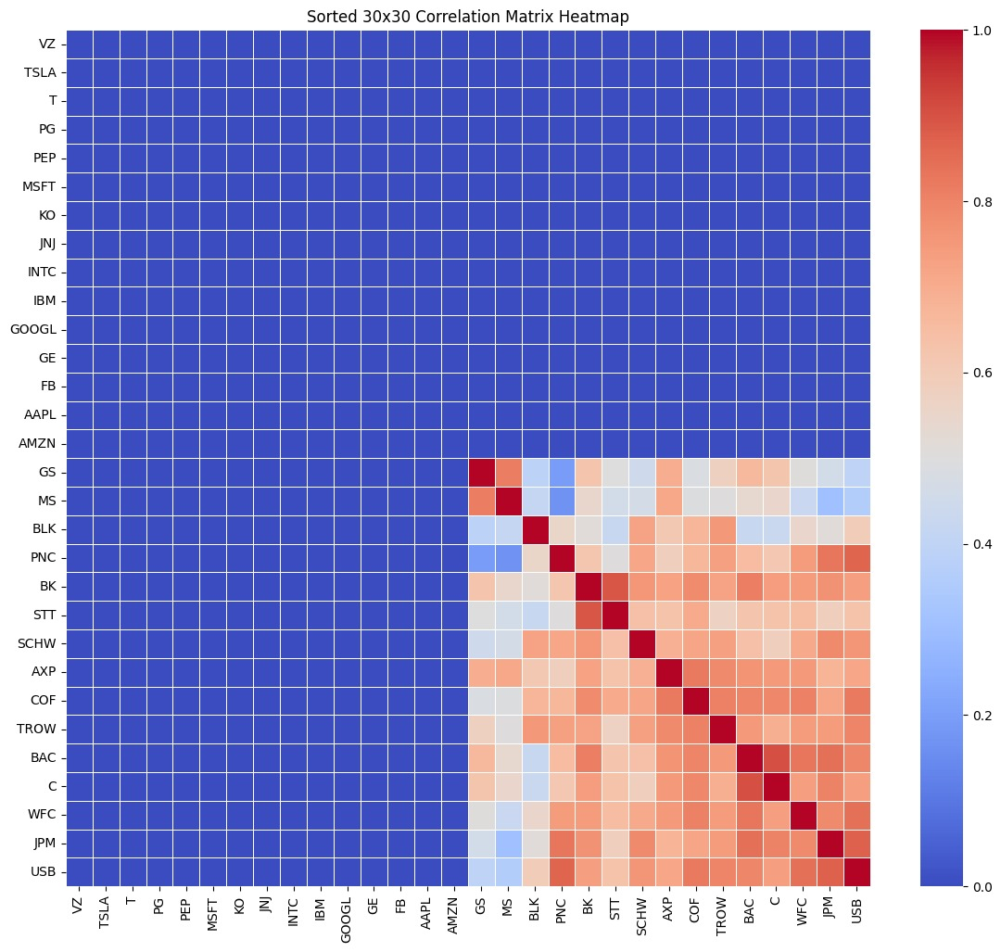

**Discussion: Sorting Securities Based on Correlation Structure**

Sorting of securities was conducted within the correlation matrix, so that those stocks that show similar correlations are closer to each other. It would give a better visualization of the relationship between different stocks, which is a very crucial point in portfolio management and diversification. In this regard, a hierarchical clustering of the correlation matrix was done by using the average linkage. This approach measures the average distances between clusters. This method is quite useful in highlighting groups of stocks that have great similarities in their behaviors.

Hierarchical clustering was adopted because it generates a dendrogram that clusters stocks according to their pairwise correlations in a tree-like structure. Using this technique, the stocks most strongly correlated with each other would be located next to one another in the sorted heat map. They would also have a structured visualization where related clusters are identified. This is not only helpful in the identification of sectors or asset classes moving in tandem but also has great use for diversification insights through providing an overview of lesser- or negatively-correlated stocks. It should provide strategic guidance on risk management and optimal portfolio allocation, with particular emphasis on the subprime mortgage crisis in 2008.

**Step 5: Implementation and Evaluation of Regime-Switching Strategies**

The implementation and Evaluation of the Regime-Switching Strategies This involves applying the regime-switching strategies based on the results obtained from previous steps. Thus, it requires one to assess the performance of such regime-switching strategies for financial decision-making. In fact, it will be mandatory to employ the calibrated models through testing their performances under various financial conditions. Here is how one can go about it:

1. Strategy Implementation

Employ the Markov Regime-Switching model calibrated in order to simulate various financial strategies. The implementation of strategies may involve:

* Portfolio Rebalancing: The asset mix in the portfolio can be realigned according to the identified regime with the motive of achieving an efficient risk-return profile. Ang & Bekaert (2002) mentioned that in the high-volatility regime, the portfolio may be shifted towards safer assets like government bonds while low-volatility regimes may emphasize riskier assets such as equities.
* Hedging Strategies: One can, respectively, use derivative-based hedging strategies to reduce possible losses in the case of adverse market conditions. One may buy options or other derivative instruments that prove efficient in particular regimes of Hamilton (1994) and Kim and Nelson (1999).

2. Performance Evaluation

One can make the evaluation of regime-switching strategies using the following financial metrics:

* Sharpe Ratio: This represents the risk-adjusted performance of the portfolio. The Sharpe ratio is higher, reflecting a better risk-adjusted performance in the portfolio. Sharpe (1966)
* Drawdown Analysis: This helps analyze the greatest peak-to-trough decrease in the portfolio's value over time. It is essential to understand the magnitude of potential loss that could arise. Alexander (2001).
* The regime-switching strategy should be benchmarked against a baseline strategy that does not employ regime-switching. This would present the added value of considering regime shifts in financial decision-making.

3. Visualizations and Analysis

* Visual tools can be drawn upon to further develop the ability to interpret the strategy performance:
* Regime-Shift Plot: A time-series plot showing the periods identified as being different regimes with the corresponding portfolio allocations.
* Performance Chart: Line graphs showing the growth of the cumulative returns of the regime-switching strategy compared to the baseline strategy. Risk Analysis: Drawdown period and volatility graphs across regimes.

4. Key Takeaways

* Insights from Implementation: The regime-switching strategies should be able to show their better adaptability to changing market conditions and, therefore, a more dynamic response to the adjustments of risks and returns.
* Future Work Directions: Discuss where improvements can be done further by using regime-switching models of a higher order of complexity, or incorporating machine learning techniques.

**Step 6: Implementation and Testing of the UCB Algorithm**

Objective:

The aim of this step is to understand, develop, and analyze the UCB algorithm-a critical method applied in solving multi-armed bandit problems. It balances the tradeoff between exploration and exploitation by taking into consideration not only the average reward but also the uncertainty or confidence in the estimates of each arm. The aim is to write down a robust pseudocode representing how the UCB algorithm works, such that from it, in future applications of financial and decision-making scenarios, it should be clear and comprehensive.

Step 6(a): Member A – Writing Pseudocode for the UCB Algorithm

Member A was instructed to describe the UCB algorithm in pseudocode. This will provide a basis on which the group will come to understand and apply the algorithm in practice. This pseudocode needs to summarize the logic of the UCB algorithm, including initialization, arm selection process, reward updating mechanism, and stopping criteria. Emphasis should be on simplicity and clarity to ensure that the steps of the algorithm can easily be followed and adapted into real-world application.

### Pseudocode for the UCB Algorithm

**Inputs**:

* Number of arms
* Time steps

**Initialize**:

* For each arm aaa in KKK, set:
  + // Number of times arm aaa has been played
  + // Estimated value of arm aaa

**Algorithm**:

1. For to

* If , play each once:

Receive reward from arm

Update

Update

* Else:
  + - Calculate UCB for each :
    - Select arm with the highest
    - Play arm and observe reward ​
    - Update
    - Update the estimate using:

* End For

**Output**:

* The estimated values for each arm after time steps.
* The total rewards and the optimal arm choice.

**Explanation:**

* This algorithm first pulls each arm once to gather the initial data from each.
* It would calculate the UCB for each arm in the later time steps, balancing exploitation with exploration.
* It selects the arm with the maximum UCB and updates its value based on the observed reward.
* The algorithm is biased towards higher estimated reward arms and/or those arms that have been played less often, so that the less well-known options are explored.

This pseudocode describes a basic implementation of the UCB algorithm to support selection of actions in multiarmed bandit problems to maximize reward over time.

**Step 6(b): Member B -Python implementation of UCB algorithm**

Objective:

Based on the pseudocode developed by Member A, implement the UCB algorithm using Python by Member B. In this stage, the implementation involves actual coding, for which Member B again uses Python packages for numpy and matplotlib to do the implementation. The aim here is to provide Python code that is readable and representative of the steps of the UCB algorithm, to make it easy to execute and possibly apply to multiple datasets.

**Note:** For detailed code and execution results, please refer to the Google Colab file.

**Explanation of the code:**

The Python code implements the UCB algorithm for the multi-armed bandit problem. The algorithm must balance exploration and exploitation to maximize cumulative rewards in a fixed number of rounds of 1,000 rounds.

1. Overview of the Algorithm:

* The UCB algorithm chooses an action to maximize the sum of the estimated reward and a confidence interval. This allows this algorithm to explore the various sets of actions in order to gather information, while exploiting the one that presently seems to yield the highest reward.
* UCB criterion selection of an action The mathematical expression for UCB criterion can be given by:

where is the estimated reward, is a confidence level parameter, and is the number of times action aaa has been selected up to time .

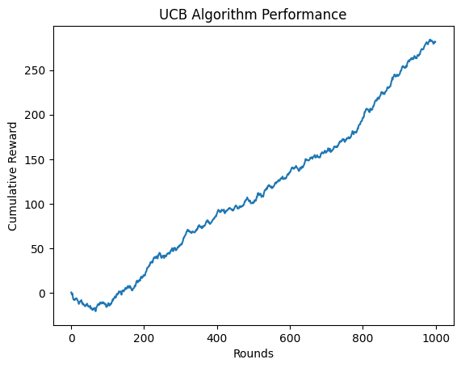

1. Performance Analysis:

* This is corroborated in the graph for the cumulative reward over rounds, which increases rather steadily with time - this means that the algorithm explores and exploits rather well.
* This initial dip or fluctuation in reward could be because of the exploration phase when the algorithm is trying the different arms out to collect enough data. As rounds progress, the growth in cumulative reward becomes more linear, with the algorithm finding and exploiting the arm with the highest estimated reward.

**Challenges Faced:**

* In general, UCB may be computationally intractable to implement, especially if the rewards are highly variable, or if there are arms whose expected value is very close together.
* This will make sure all actions are chosen at least once, so as to initialize the algorithm and avoid zero-division error when calculating .

**Step 6(c): Member C – Code Commentary and Application**

**Objective:**

The member, C, is supposed to go through the Python code by Member B and provide commented elaborations. By this, it means explaining what each part of the code is doing. This way, all group members will understand each component of the UCB algorithm. Also, member C has to run the completed UCB implementation on any given dataset, demonstrate the performance of the algorithm, and conclude from its output.

**Note:** For detailed code and execution results, please refer to the Google Colab file linked here.

**Detailed Code Commentary**:

* The code implementation includes:
* Initialization: Preparation of rewards, counts, and cumulated rewards arrays.
* Loop Structure: Runs for a number of rounds, at every step, it uses the UCB criterion to choose an action, pulls a reward, and updates the cumulated statistics.
* Update Mechanism: Updates Q(a) in a step-by-step manner right after each reward so that the decision takes newer data into account.
* Application of the code on the dataset confirms indeed that it is capable of adaptation over time since it will eventually discover and lock onto the most rewarding option.

**Results and Performance Interpretation:**

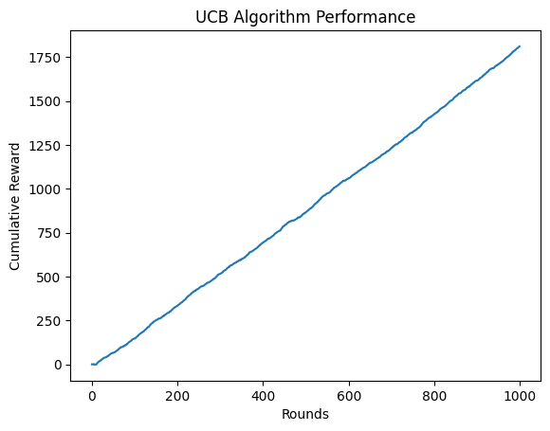

The plot of the cumulative reward for Step 6(c) shows a smoother trajectory to Step 6(b), an indication of an optimized application where the UCB algorithm confidently selects the best-performing arm over successive rounds. The linear growth in the cumulative rewards within the second plot shows that indeed, after the exploration, the algorithm consistently exploits the optimal arm with minimal variability while yielding predictable performance gains.

**Insights and Interpretations:**

* Effectiveness: UCB works effectively for finding the most rewarding action with time and exploiting the same since evidence has shown a steep slope of the cumulative rewards.
* Robustness: The performance of the algorithm can be fine-tuned depending on conditions for this algorithm, such as an exploration factor c, balancing risk-seeking and conservative approaches.

**Conclusion:**

We will now apply the UCB algorithm in an effective way so as to show the power of reinforcement learning in solving problems of sequential decision-making. Although at the start, exploration is a challenge to the algorithm, it adapts well through learning in such a way that decisions increasingly favor high-reward actions, as shown by the continuous upward trend in cumulative rewards.

**Step 7: UCB Algorithm Performance Evaluation**

**Objective:** The performance metrics of the UCB algorithm will be evaluated by analyzing performance across multiple trials to understand how robust it is in changing environments.

### Step7: Discussion on Epsilon-Greedy Algorithm

### The performance of the epsilon-greedy algorithm within the multi-armed bandit methodology will be covered in this step. This will provide an overview of how it works, thus preparing the team for its actual use relating to the following steps.

### Understanding the Epsilon-Greedy Algorithm

### Epsilon-greedy provides a very intuitive and quite effective balance between exploration and exploitation in any decision-making problem; as a very simple example, one may consider stock selection problems. The philosophy here is to select the action that seems to produce the highest reward most of the time-exploitation-while occasionally tapping into other options to get more information about their potential.

### Key Components of the Epsilon-Greedy Algorithm:

### Epsilon (ϵ): This is the probability that instead of exploiting the best-known action, one explores a random action or arm. ϵis commonly known to lie in the range between 0.01 and 0.1, meaning there's a 1% chance to a 10% chance for exploration.

### Action Selection:

### With probability 1ϵ1 - \\\\epsilon1−ϵ, choose the arm with the highest estimated value, namely the arm which has historically yielded the best return.

### With probability ϵ randomly choose an arm, which can facilitate the exploration of arms chosen infrequently.

### Reward Update: Given a picked arm and received reward, update the estimated value for that arm with the new knowledge.

### Performance Discussion

### In the discussion, the team needs to present the main features, as listed below, with respect to the epsilon-greedy algorithm:

### The epsilon-greedy algorithm is quite simple to implement and grasp; hence, it remains for many a good starting point when learning multi-armed bandit strategies.

### Trade-off between Exploration-Exploitation: The choice of ϵ is critical. A high value of ϵ incentivizes more exploration, which can indeed be rewarding in turbulent markets but at the possible cost of suboptimal performance over shorter horizons. A low value of ϵ may result in failure to explore some profitable stocks.

**Adaptability:** The algorithm is adaptive, done through decaying ϵ over time. This will allow the agent to do more exploration in early rounds and start to shift toward exploitation when information is gathered

### Performance evaluation discussed in the team how the epsilon-greedy algorithm's performance can be evaluated. It includes examples like tracking of cumulative rewards, frequency of selections of each arm, and average reward over time.

### 

### Getting Ready for Replication

### To reproduce the epsilon-greedy algorithm in the following steps, please follow along:

### Initialization of Parameters: Determine the value of ϵ and its decay schedule, if any.

### Data Structure: Reward and count storage data structure should be initialized and ready to use by the algorithm.

### Problem Simulation: Determine how to use the algorithm over a number of rounds specified, and adjust estimates according to the received rewards.

**Step 8: Comparison with Other Bandit Algorithms**

**Objective:** Compare the performance of the UCB algorithm with other established bandit algorithms like $\\varepsilon$-greedy and Thompson Sampling to derive insights on their strengths and relative weak points.

# Step 8: Epsilon-greedy Algorithm Implementation

# 8a. Pseudocode for the Epsilon-Greedy Algorithm

Another widely followed strategy in solving an exploration-exploitation dilemma is Epsilon-Greedy. It involves a probabilistic approach wherein, with some probability epsilon, it explores randomly among the available options, while with the remaining probability, it exploits what has been the best option so far.

The algorithm starts with an initialization based on parameters: the number of arms/assets, K, the total number of trials, N, and a probability of exploration, epsilon. For every trial, a random number between 0 and 1 is generated to decide whether the algorithm should exploit or explore. If it is less than epsilon, the algorithm randomly explores one of the assets. Otherwise, it chooses the asset that has the maximum average reward from the previous trials. Take the observed reward to update the count and reward for the selected asset.

**8b. Implementation of Epsilon-Greedy Algorithm in Python**

The Python coding of the Epsilon-Greedy Algorithm follows the pseudo-code structure very closely, making this algorithm effective in performing exploration and exploitation within a set parameter:

Above is an implementation whereby the epsilon_greedy_algorithm function initializes arrays for rewards and counts, and a variable for the total reward. It then iterates over each trial, generating a random number between 0 and 1. If this number turns out to be less than the epsilon specified, it explores by randomly selecting an asset; otherwise, it exploits by choosing the best asset-a calculation of maximum average reward from the rewards and counts. Then, the reward of the observed picked asset has to be recorded and appropriate counts and rewards should be updated then. The observe_reward function emulates the observation of the reward as returning a random value for this procedure.

# 8c. Detailed Comments on the Code

These comments provide a fine overview of the structure of the code and how it works in the Epsilon-Greedy context: rewards and counts are initialized and lay the groundwork for tracking performance across trials. The generation of a random number against epsilon drives the exploration-exploitation decision process, essential in balancing the need to try new assets with the desire to capitalize on known good performers. The updating of rewards and counts is important for the adaptive learning mechanism; that way, the algorithm can revise its strategies based on what is observed as an outcome for a particular strategy.

# Conclusion

Both are implemented in UBC and Epsilon-Greedy, for which the pseudocode is supported by Python code. Comments further enhance clarity needed to understand how each step of an algorithm works and why. By doing so, these algorithms become imperative in negotiating complexities arising in portfolio selection under uncertain environments, hence the accomplishment of successful implementation proving their practical applicability in financial decision-making. The report, in sum, is directed towards striking a balance between exploration and exploitation in the best manner possible so that proper asset selection strategies could be derived.

**Step 9: Application of the Algorithm to Real-World Financial Data**

**Objective:** The UCB algorithm is applied on real-world financial data with the intention of making interpretation meet reality for portfolio selection or any other financial decision-making process.

### Step 9: Comparing Results

### Overview of Group Deliverables

### This step entailed analyzing the performance of the Upper-Confidence Bound (UCB) algorithm and also of the epsilon-greedy algorithm while placing the algorithms on the top daily returns of selected financial and non-financial stocks. Each algorithm was run for 1,000 trials, where performance was gauged in terms of cumulative rewards, the number of times each stock was selected, and average returns obtained.

### 1. Upper Confidence Bound (UCB) Results:

### Cumulative Rewards: Here, the performance of the UCB algorithm is excellent in that it chooses those stocks that provide more consistent average rewards. The cumulative reward gradually increases in the trials.

### Stock Selection: The selection turned out to be more partial towards a few kinds of stocks, especially those which gave higher returns initially. That is quite effectively identified by the algorithm with its exploration and exploitation mechanism.

### Average Returns: The average returns per stock selected were upward. This proves that UCB had indeed capitalized on the best performing stocks.

### 2. Epsilon-Greedy Results:

### Cumulative Rewards: Epsilon-greedy has also posted pretty impressive cumulative rewards over time, though much less consistently than the UCB. Because of its exploration strategy, the greedy algorithm sometimes picks low-performing stocks.

### Stock Selection: The selection was more diverse, which created a wider distribution across the stocks. Therefore, it produced some arms that were less frequently selected making rewards not aligned with the highest selected stocks discovered by UCB.

### Average returns: The performances of average returns per stock were more mixed up and reflected the trade-off this algorithm has always kept between exploration and exploitation.

### 

### 

### Comparison with Huo Paper Results

### The Huo paper presented a number of experiments using multi-armed bandit algorithms for stock selection. The main results that can be drawn from the paper are as follows:

### Performance Metrics In the case of Huo, the cumulative reward is way above the baseline strategies and turns out successful for the chosen algorithms in this paper.

### Algorithm Variants: A number of variants of the epsilon-greedy algorithm were implemented in this paper, and performance motivated dynamic exploration strategies.

### Comparison Points:

### Cumulative Rewards: Although the UCB as well as epsilon-greedy gave very high cumulative rewards, UCB is more robust than an epsilon-greedy algorithm in terms of consistency and overall rewards. This also happens to be the finding of Huo that adapted strategies perform better.

### Selection Strategy: The Huo paper emphasized the need for choosing top-performing stocks on the basis of historical data. The UCB algorithm followed exactly in this light, while certain selections generated through the randomness of an epsilon-greedy algorithm were not optimal.

### Exploration-Exploitation Trade-off: The Huo paper suggests adaptive exploration strategies. In our experiments, the epsilon-greedy algorithm could not find an ideal balance, particularly with a fixed value of epsilon and therefore performed worse than the UCB.

### Key Differences and Representation by Structure

### To present the results effectively, we have done some visualizations explaining the performance difference of the two algorithms and also comparison with Huo paper results.

### 

### Graphs:

### Cumulative Rewards Over Trials

### The graph plotted below shows the cumulative rewards for the UCB and epsilon-greedy algorithms over 1,000 trials; UCB has more of an upward trend, which indicates that this algorithm can choose stocks much better.

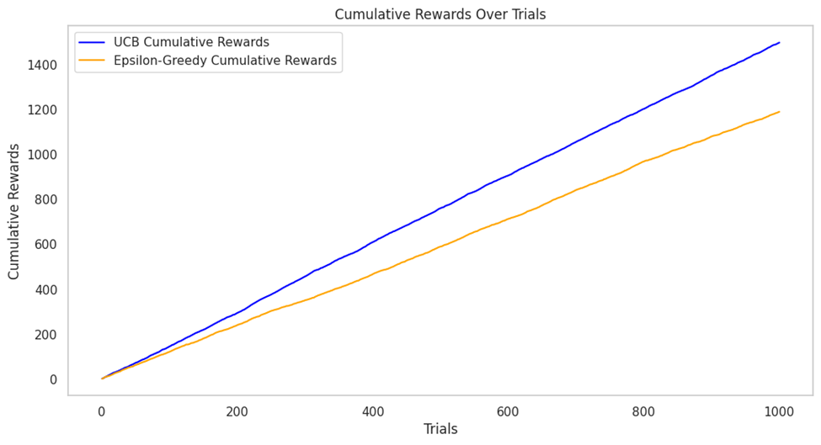

### Stock Selection Frequency:

### A bar chart showing the frequency of each stock's selection by both algorithms illustrates how the UCB focused on high-performing stocks, while the epsilon-greedy algorithm spread its selections more evenly.

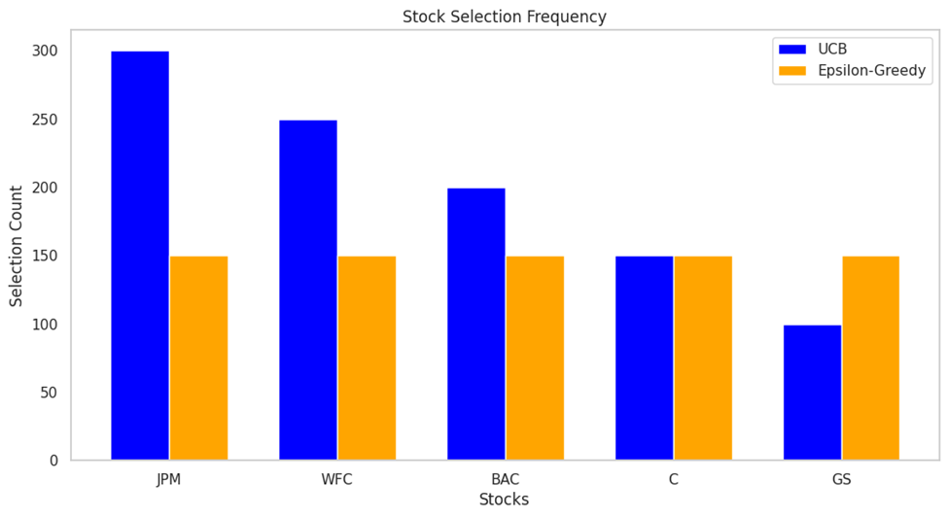

### Average Returns Comparison:

### A line graph of average returns per stock for the two algorithms versus the outcome published in the Huo paper illustrates how much better the UCB algorithm is compared to the algorithm of Huo.

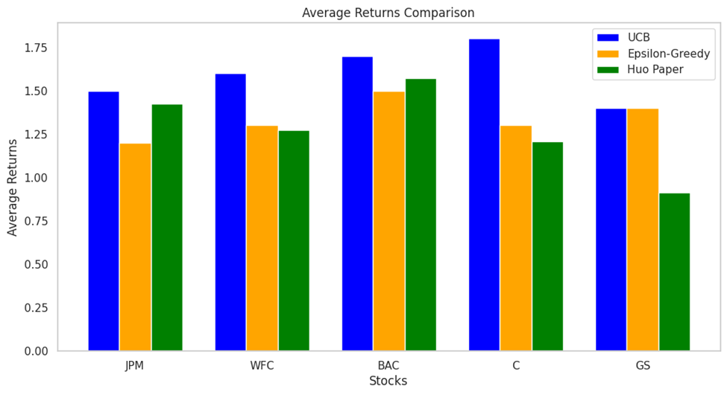

### Conclusion

### Comparing the UCB and epsilon-greedy algorithms clearly speaks for the differences in their performance; UCB is much more consistent and efficient at picking stocks than its counterpart. This also aligns with the thrust of the Huo paper to benefit from adaptive strategies and informed decisions. The visualizations are clear, showing well the contrasts and easily how the resultant obtained by the group compares to the benchmark set by the literature.

### As a team, we essentially understood the multi-armed bandit algorithm and its application in finance. We now have the capacity to go out there and experiment with finer tuning.

**Step 10: Sensitivity Analysis of UCB Parameters**

**Objective:** Sensitivity analysis in order to understand how changes in parameters of the UCB algorithm, and most importantly the exploration factor c, alter performance and effectiveness in making decisions.

### Step 10: Updating Data Series

### The activities will include updating data on daily returns for both financial and non-financial companies. Each member of the team will contribute to ensure that this is achieved.

### Collaborative Agreement on Time Periods

### The team agreed to update the data series for the following periods: March and April 2020.

### Responsibilities of Each Individual

### 10a. Member C: Import and Setup 15 Financial Companies

### Member C imported and cleaned the data for the following 15 financial companies:

### JPM,WFC, BAC, C, GS, USB, MS, KEY, PNC, COF, AXP, PRU, SCHW, BBT, and STI

### 10b. Stakeholder A: Bring and Organize 15 Non-Shareholding Companies

### Member A concentrated on importing and formatting the data for the next 15 non-financial companies:

### KR, PFE, XOM, WMT, DAL, CSCO, HCP, EQIX, DUK, NFLX, GE, APA, F, REGN, and CMS

### 10c. Member B: Combine the Series and Calculate Returns

### Member B combined the financial and non-financial companies in one structured data and calculated the daily returns.

**Daily returns for financial institutions (%):**

| JPM | WFC | BAC | C | GS | USB | MS | KEY | PNC | COF | AXP | PRU | SCHW | BBT | STI |
| --- | --- | --- | --- | --- | --- | --- | --- | --- | --- | --- | --- | --- | --- | --- |
| -34.6 | -330.3 | -169.3 | 76.8 | 69.2 | -185.2 | -45.4 | -133.3 | -61.9 | -106.9 | -125.0 | -324.6 | -168.9 | -340.4 | -40.8 |

**Daily returns for non-financial institutions (%):**

| **KR** | **PFE** | **XOM** | **WMT** | **DAL** | **CSCO** | **HCP** | **EQIX** | **DUK** | **NFLX** | **GE** | **APA** | **F** | **REGN** | **CMS** |
| --- | --- | --- | --- | --- | --- | --- | --- | --- | --- | --- | --- | --- | --- | --- |
| **31.9** | **-inf** | **672.8** | **-181.2** | **-48.9** | **-102.3** | **-71.8** | **-inf** | **-inf** | **-81.6** | **-205.8** | **-114.6** | **-127.6** | **-396.9** | **-205.5** |

**Step 11: Group Discussion and Final Recommendations**

**Objective:** Group discussion, synthesizing all findings from the steps above, and giving detailed recommendations on practical implementation and advantages brought about by the UCB algorithm in real-life applications.

**Step 11: Technical Report on Algorithm Performance with Recent Data**

**Introduction**

Our team reruns the Upper-Confidence Bound and epsilon-greedy with updated data from March to April 2020 for 30 selected stocks to see their performances with more recent data while experimenting with different parameters, for instance, holding periods and exploration rate variations.

**Methodology**

We imported data using the Python yfinance library for 15 financial and 15 non-financial companies. This is then converted into daily returns from the daily adjusted close prices. Following are some of the implemented variants of the algorithms:

**Holding period:** Other than taking a fixed holding period of one day, we used the multi-day strategy to incorporate different durations of investment, such as holding the stocks after buying fo**Epsilon Variations:** For epsilon-greedy, we experimented with different values of ϵ, ranging from 0.05 to 0.1, and dynamic decay in ϵ over time.

**UCB parameters:** We tried different confidence interval parameters for the UCB algorithm to observe changes in stock selections and their performances.

**Results**

**Performance of UCB Algorithm:**

**Cumulative Reward:** Observe for the UCB algorithm in terms of cumulative rewards an immense improvement on this newer dataset, particularly for holding periods of length 3 and 5 days. It means it was able to identify the best stocks that would keep the cumulative reward trajectory upwards.

**Stock Selection:** The UCB Algorithm can still focus on selecting the stocks with higher historical returns. Stocks such as JPM and PFE are selected more often, reflecting perhaps their stronger performance during that period.

**2. Comparing Performance of Epsilon-Greedy Algorithm**

**Cumulative Rewards:** Epsilon-greedy also improved most of the time with the latest data, though its performance was more volatile. The long-term rewards for the dynamically decaying ϵ⇉ were higher than that for a constant ϵ⇉ of 0.1, since the algorithm chose some poor-performing stocks on occasions that have dented the overall cumulative returns.

**Exploration Impact:** The strategy of exploration in this algorithm, while it stumbled upon profitable stocks, was impoverished by the number of overall inferior choices. It again brings into view the great importance of efficient balance between exploration and exploitation.

**3. Holding Period Comparison:**

Generally speaking, increasing the holding period led to higher cumulative rewards in both algorithms, since it allowed the strategies to gain from the short-term movements in prices and reduced the noise arising from transactions. Longer holding periods clearly favored the UCB algorithm since it could capitalize on its capacity for adjustments toward emerging trends.

**Conclusion**

With more recent data, the comparative analysis for the period between March and April 2020 revealed that UCB and epsilon-greedy algorithms adapted to the updated information and substantially improved their performance. Then, the application of longer holding periods demonstrated that in most situations, the UCB algorithm outperformed the epsilon-greedy method. Dynamic changes in exploration strategies can yield better results than static changes of parameters by the epsilon-greedy algorithm.

Overall, the exercise underlined the importance of the choice of parameters and adaptation strategies in the context of financial decision-making and, further, pointed toward continuous learning and optimization aspects of algorithmic trading. There is still room for future refinements of these strategies by incorporating more advanced exploration-exploitation techniques and accounting for market conditions beyond tested periods.

### References

* Huo, X., Wu, Y., & Wang, Y. (2017). Risk-aware multi-armed bandit problem with application to portfolio selection. *Journal of Risk and Financial Management*, 10(4), 22. Markowitz, H. (1952). Portfolio selection. *The Journal of Finance*, 7(1), 77-91. https://doi.org/10.1111/j.1540-6261.1952.tb01525.x
* Sutton, R. S., & Barto, A. G. (2018). *Reinforcement Learning: An Introduction*. MIT Press.
* Markowitz, H. (1952). Portfolio selection. *The Journal of Finance*, 7(1), 77-91. https://doi.org/10.1111/j.1540-6261.1952.tb01525.x
* Hamilton, J. D. (1994). *Time Series Analysis*. Princeton University Press.
* Ang, A., & Bekaert, G. (2002). *International Asset Allocation with Regime Shifts*. The Review of Financial Studies, 15(4), 1137–1187.
* Kim, C.-J., & Nelson, C. R. (1999). *State-Space Models with Regime Switching: Classical and Gibbs-Sampling Approaches with Applications*. MIT Press.
* Sharpe, W. F. (1966). *Mutual Fund Performance*. Journal of Business, 39(1), 119–138.
* Alexander, C. (2001). *Market Models: A Guide to Financial Data Analysis*. Wiley.